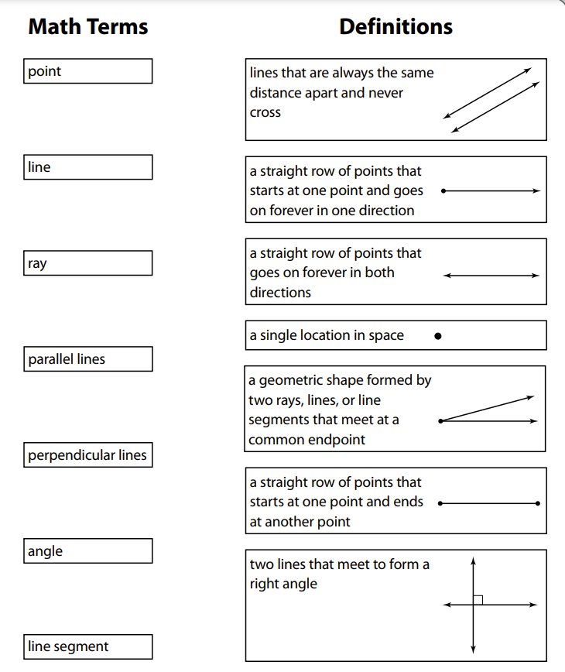

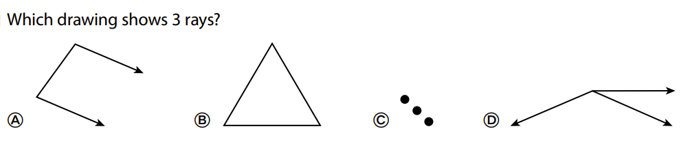

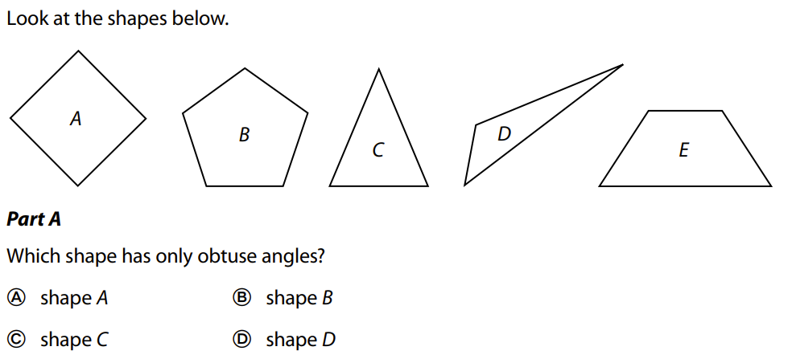
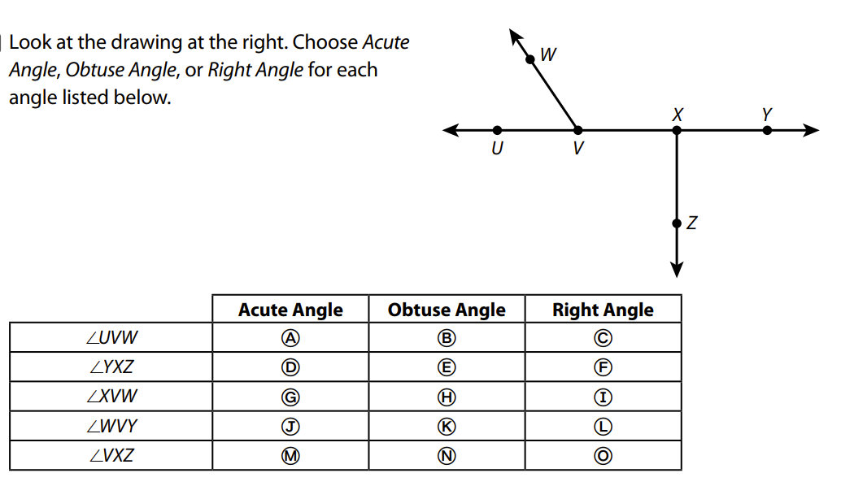

Circle all the letters below that contain acute angles:
A B C D E F G H I J K L M
N O P Q R S T U V W X Y Z

Circle all the letters below that contain right angles:
A B C D E F G H I J K L M
N O P Q R S T U V W X Y Z

Circle all the letters below that contain obtuse angles:
A B C D E F G H I J K L M
N O P Q R S T U V W X Y Z

