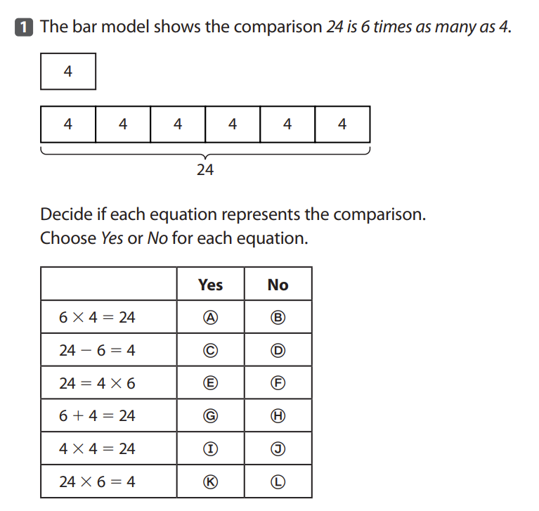
Multiplicative Comparisons:

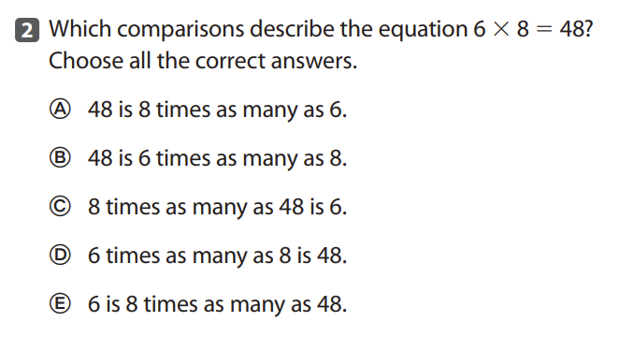

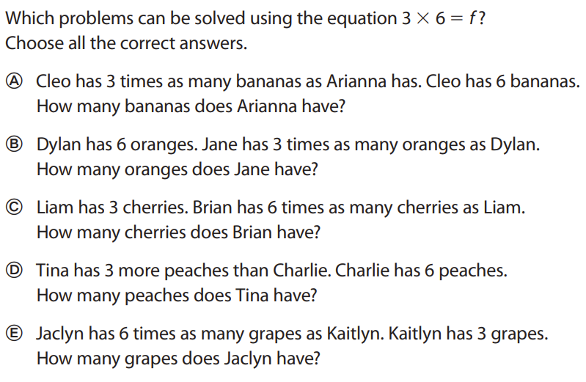
3)

Multiplication:

4) 3,412
X 4__

5) 27
X 17__

6) 295
X 13__

Division:
7) 6,128 3 =

8) 3,036 12 =

Multiplication & Division Word Problems:

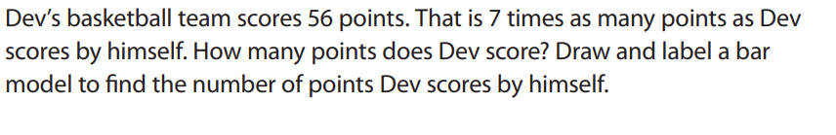
9)

10) Annette reads 22 pages every day. How many pages will she have read after 6 days?

11) The ferry can hold 8 cars. How many trips will it have to make to carry 25 cars across the river?

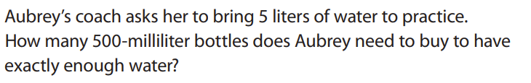
12)

13) Ms. Smith started making this study guide at 4:30 p.m. and it took her 57 minutes to finish it. What time did Ms. Smith finish making the study guide and finally get to go home?

