Dear Students and Parents,
The following study guide will take you through the ideas and skills that we’ve been studying throughout the narrative unit while reading, The Tiger Rising and your own personal independent reading books. This guide will allow you to see the types of questions that will be addressed, the rubric used to grade the responses, as well as the learning progression of each skill.

Side note: The learning progression shows growth through multiple grades with fourth grade being the goal. Some students may meet the goal at the end of this unit, while others may need further instruction throughout the year, which is okay. The learning progression shows the yearend goal.

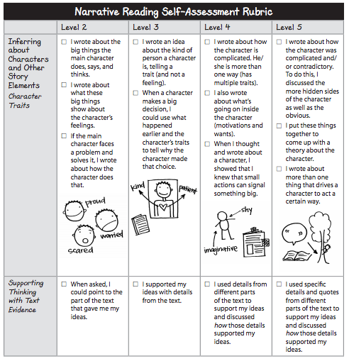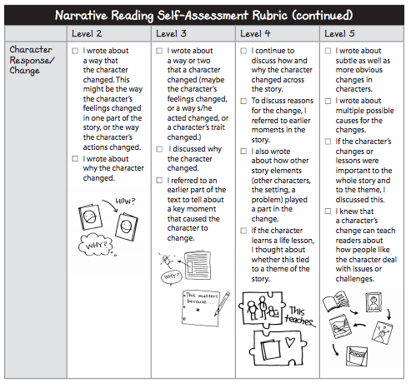

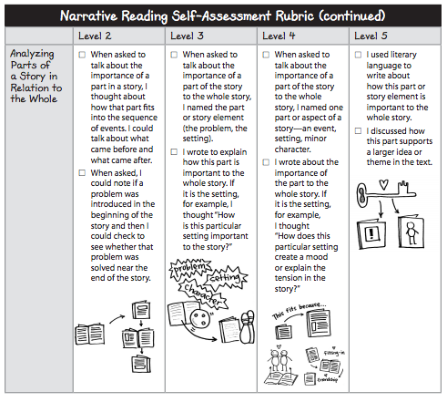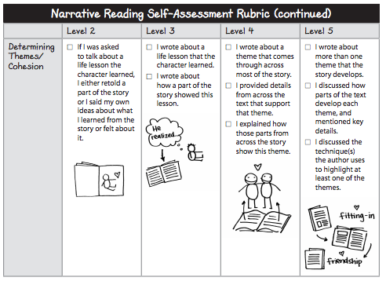
Skill: Inferring About Characters and the Other Story Elements: Character Traits, Supporting Thinking with Evidence
- Show that you know the character is complicated (for example, tell about more than one trait)
- Tell about the character’s motivation(s)
- Give details from different parts of the story that support your understanding of the character

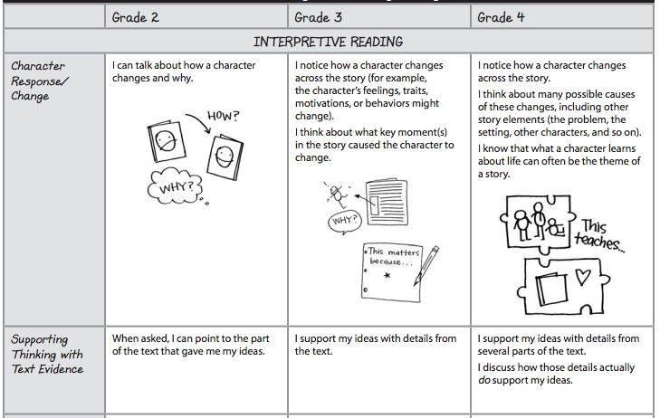

Sample Question:
- What kind of person is __________? (Insert the name of a main character from a current book that you are reading.)

Skill: Character Response/Change
- Describe one or two ways the character changes
- Explain what caused the change
- Include how different story elements (other characters, setting, key events) contributed to the change

Sample Question:
- How did ____________ (insert main character) change from the beginning to the end of the story and why?

Skill: Analyzing Parts of a Story in Relation to the Whole
- Name the story element that you are highlighting in this part of the story (character, setting, plot, mood/feeling, important object)
- Explain how this part fits with other parts of the story
- Use words like tension, resolution, setting, or other words that show you know about the story elements or narrative craft.

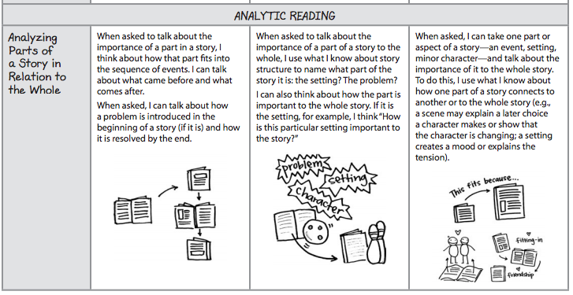

Sample Question:
- Select a small section of your independent reading book and tell how this part of the story is important to the whole story.

Skill: Determining Theme/Cohesion
- Write about how a theme that comes through in different parts of the story
- Discuss parts from early and late in the story that show this theme
- Explain how those parts from across the story support this theme

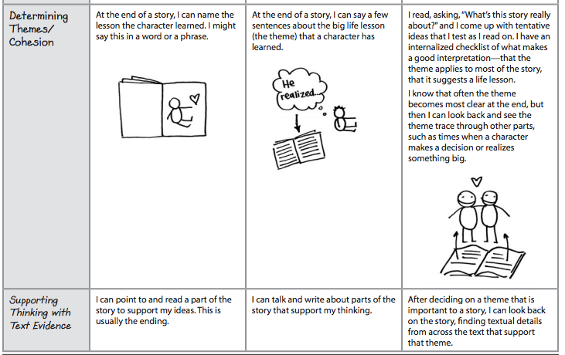

Sample Question:
- Write about a theme (or life lesson) that your independent story develops. Use details from the story to support your answer.

Sample Responses: Inferring About Characters and the Other Story Elements: Character Traits, Supporting Thinking with Evidence

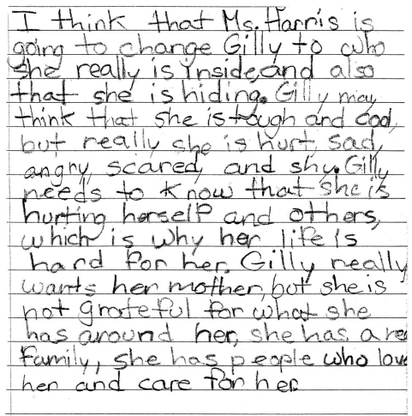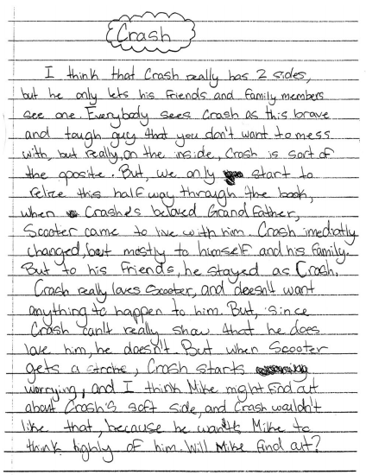

Sample Response: Character Response/Change

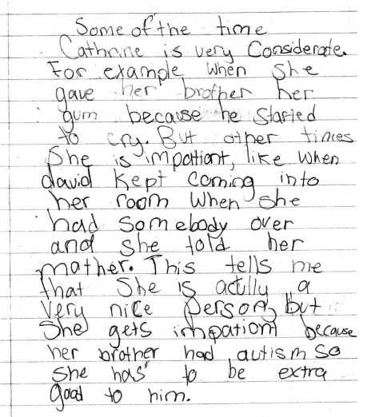

Sample Responses: Analyzing Parts of a Story in Relation to the Whole

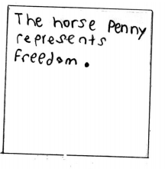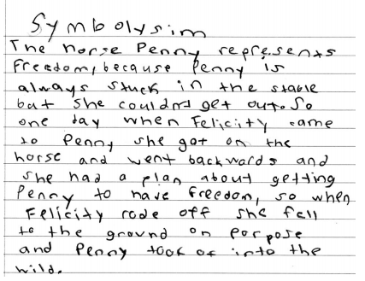

Sample Responses: Determining Themes/Cohesion

