The Water Cycle Song!
(To the the tune of “She’ll Be Coming Around the Mountain”)
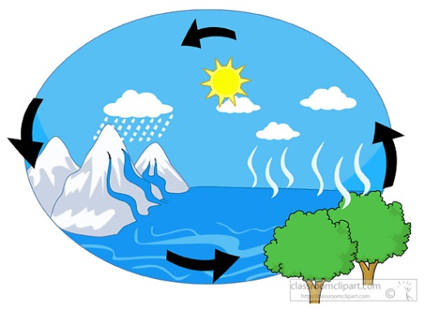
Water travels in a cycle, yes it does!
(use pointer finger to make a big circle)
Water travels in a cycle, yes it does!
(repeat finger circle)
It goes up as a evaporation
(moves hands to the sky)
Forms clouds as condensation
(make a cloud overhead with arms)
Then it comes down as precipitation, yes it does! (Yes it does!)
(sprinkle with fingers while bringing arms down in front of you)

