Grade 4, Unit 2, Reading the Weather, Reading the World
SESSION 4 HOMEWORK
TALKING ABOUT YOUR CHALLENGE BOOK READING
Readers, tonight, as you read a nonfiction text or two, keep reading and tackling the hard parts of your challenge books. You might also take a moment this evening to talk about your books with a reading friend or family member. Researchers who study learning say that talking about reading is one of the most powerful things you can do to become a better reader. Some possible points of discussion could be:
• Talk about your book’s subject. What are you learning? What does your family know about your topic?
• Talk about how your nonfiction book is challenging in a good way. What’s tricky? How are you tackling reading challenges?
Enjoy your conversations!

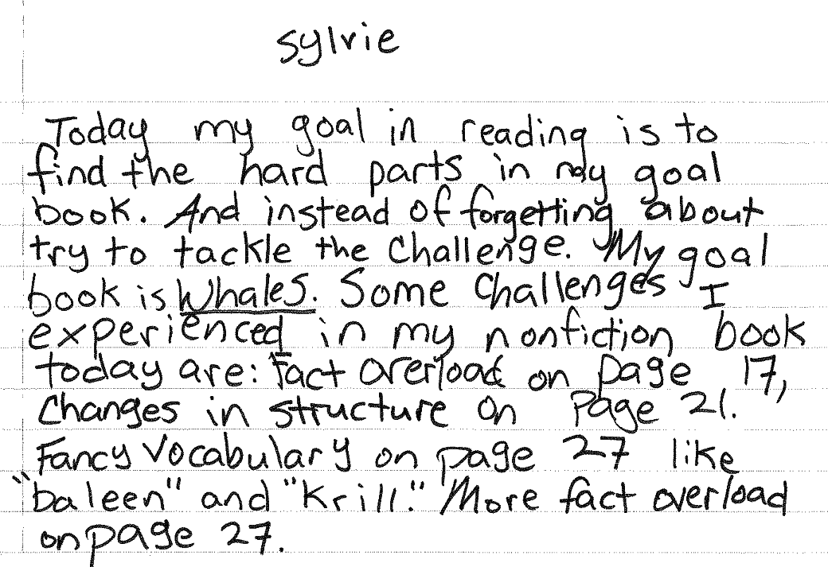
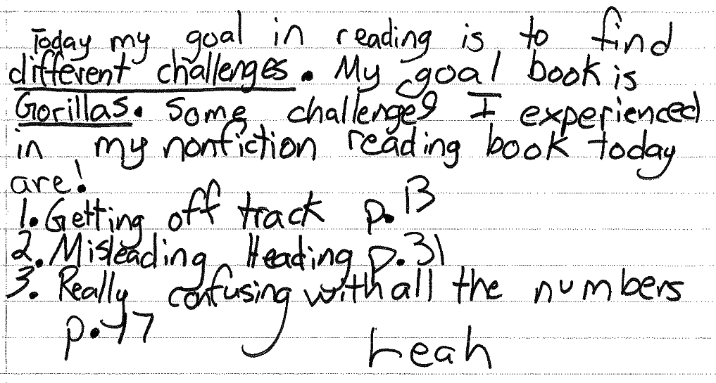
Fig. 4–1 Sylvie and Leah reflect on their conversation about their challenge books.

