Grade 4, Unit 2, Reading the Weather, Reading the World
SESSION 2 HOMEWORK
REFLECTING ON YOUR NONFICTION READING LIFE
Readers, tonight continue digging into nonfiction texts. Find and read them everywhere you can! Read the sports page. Read the video manual. Read the back of the Lucky Charms cereal box.
As you do that nonfiction reading tonight, notice how you are doing it. Think about what is working for you. What isn’t working for you? How can the work you do in school make a difference in your reading life outside school?
As you do that reading, here is an important challenge. After you have read, create two ways to represent your reading work in your reader’s notebook. First, make a page that will divide the notebook between the fiction and nonfiction portions. Use this divider to represent your nonfiction reading life. Decide whether you will use it to show the places you read, the kinds of nonfiction you read, the topics you like best, the strategies you use when you are reading nonfiction, or anything else that matters about you and nonfiction reading. You can use pictures, words, boxes and bullets, diagrams, maps—whatever you want.
After you have made the divider page, would you also write about your nonfiction reading, making the first entry in this portion of your reader’s notebook? Record insights you have about yourself as a nonfiction reader, and resolutions, too. Come to school prepared to share these and talk about them.
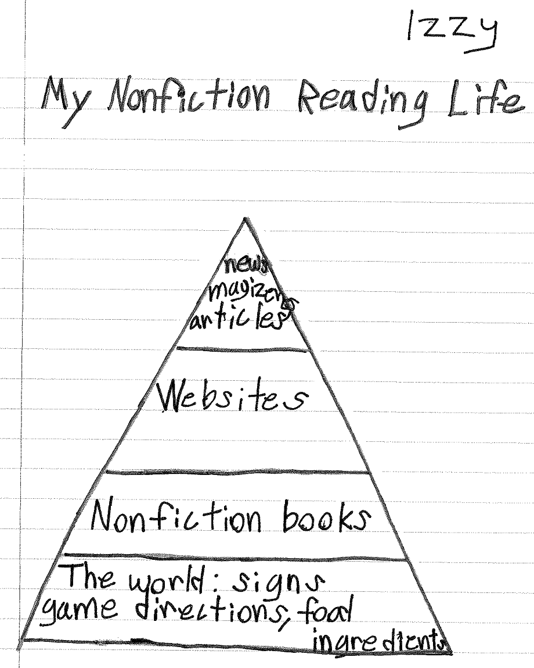
Fig. 2–1 Izzy creates a diagram of her nonfiction reading life.

