Grade 4, Unit 2, Reading the Weather, Reading the World
SESSION 1 HOMEWORK
BUILDING YOUR NONFICTION READING LIFE
Readers,
Earlier today, you searched your backpacks for an answer to the question, “What sorts of nonfiction already fills my life?” Tonight I hope you continue to think about this and also try to make your nonfiction reading life richer. Think about the things you love—a sport, an author, a music group, an animal, a cause, a place, a game. There are nonfiction texts connected with that topic. Your job tonight is to try to find some of those texts.
This may mean searching online for websites on the topic, it may mean going to the school or local library to research books, or it may mean asking people (including me and your family) for help.
A final option is to bring home the books you are reading in school and continue reading them. The most important thing for now is that you are reading nonfiction at home as well as at school. Continue to read without doing any writing about your reading, and be sure to use your reading log to record the amount of reading you are doing.
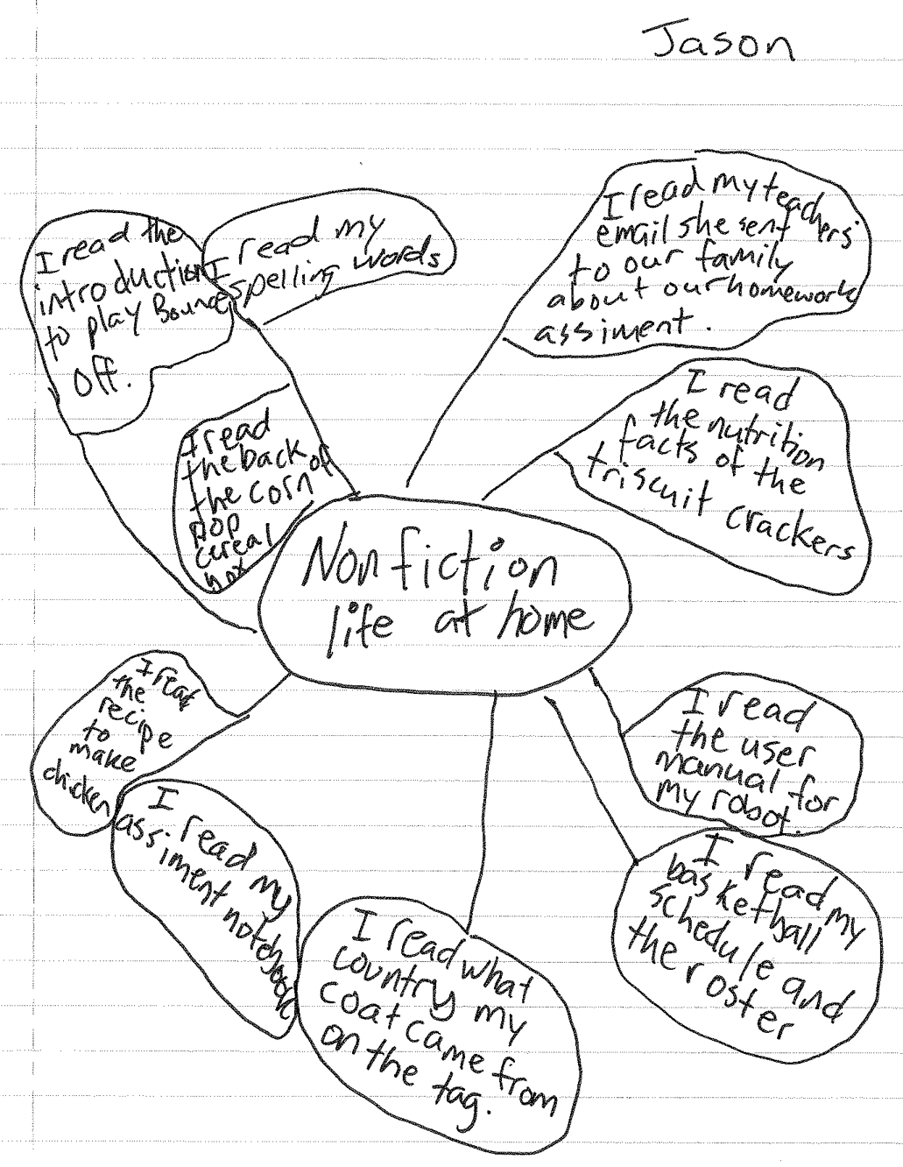
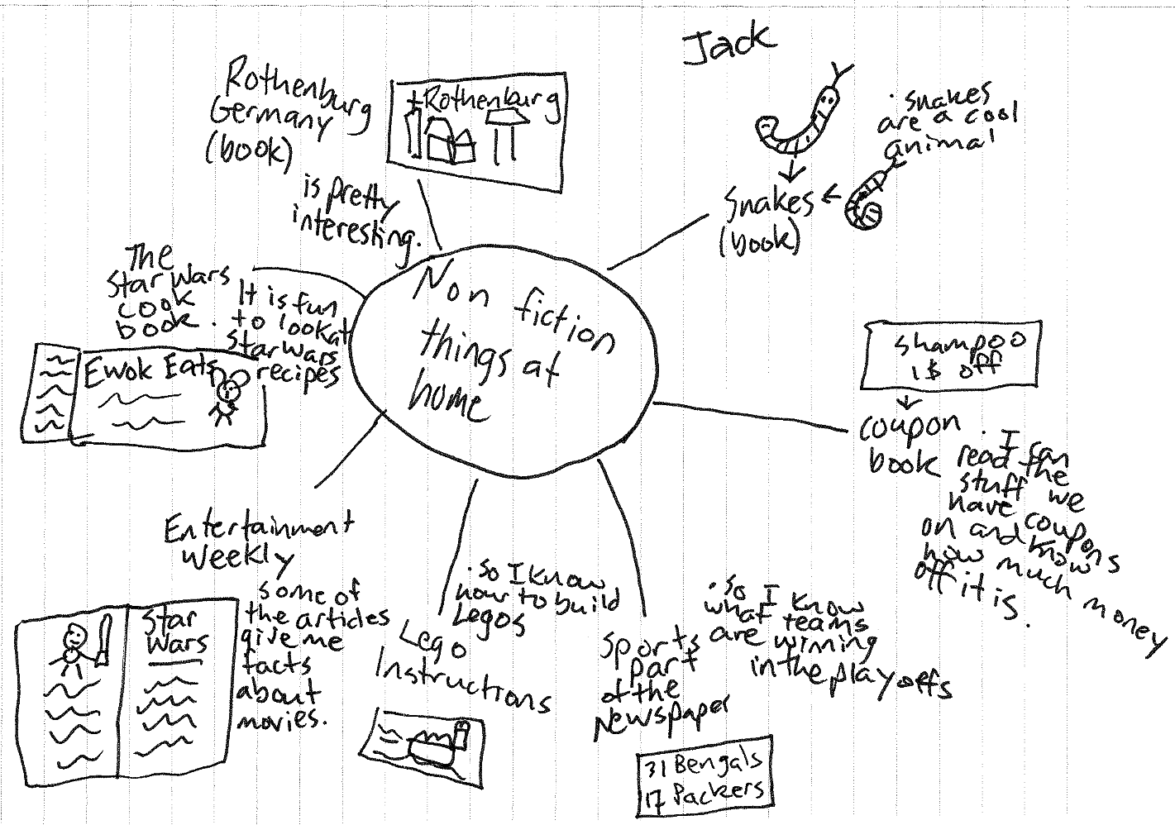
Fig. 1–2 Nonfiction that fills Jason’s and Jack’s lives

