**New Prospect Elementary School**

**School to Home Math Engagement for Families**

**Fourth Grade: 2023-2024**

|  |  |  |
| --- | --- | --- |
| **Math Unit** | **Links to Resources (Parents)** | **Links to Resources (Teachers)** |
| **Unit 1**  **Making Relevant Connections with Place Value Understanding, Addition and Subtraction of Whole Numbers** | [Comparing Numbers](http://www.aaamath.com/cmp.htm)  [2048 - Game](https://www.mathgametime.com/games/2048) | [Illustrative Mathematics](https://im.kendallhunt.com/k5/teachers/grade-4/units.html)  [Would You Rather Math Questions?](https://www.wouldyourathermath.com/category/place-value/)  [Open Middle](https://www.openmiddle.com/sum-to-10000/)  [Art of Questioning](https://thinkingpathwayz.weebly.com/artofquestioning.html) |
| **Unit 2**  **Exploring Real-Life Phenomena Through Patterning and Algebraic Reasoning** | See hands-on activities below. | [Illustrative Mathematics](https://im.kendallhunt.com/k5/teachers/grade-4/units.html)  [Which One Doesn’t Belong?](https://wodb.ca/)  [Number Tiles](https://www.openmiddle.com/wp-content/uploads/2019/11/Number-Tiles-0-to-9.pdf)  [Wonderopolis – What is a Prime Number?](https://wonderopolis.org/wonder/what-is-a-prime-number)  [Code Breaker](https://nrich.maths.org/1172)  [Random Number Generator](https://pickerwheel.com/tools/random-number-generator/)  [Eating From Ecosystems Investigative Task](https://lor2.gadoe.org/gadoe/file/8e26d11d-11fd-40ff-8464-77330bb91d79/1/Eating-from-Ecosystems-Grade-4-Unit-2-Investigative-Task.pdf) |
| **Unit 3**  **Reasoning about Multiplication and Division** | [Multiplicative Thinking](https://mathathome.mathlearningcenter.org/grade/4/set-1)  [Partial Product Finder](https://apps.mathlearningcenter.org/partial-product-finder/)  [Interactive Clock](https://apps.mathlearningcenter.org/math-clock/) | [Illustrative Mathematics](https://im.kendallhunt.com/k5/teachers/grade-4/units.html)  [Multiplicative Thinking](https://mathathome.mathlearningcenter.org/grade/4/set-1)  [Penny Cube Activity](https://mikewiernicki.com/penny-cube/) |
| **Unit 4**  **Investigating Fractions and Decimals** | [Fraction Strips](https://toytheater.com/fraction-strips/)  [Line Plot Family Fun](https://drive.google.com/file/d/1fdknTsbW3HrclF0cceWvfJPxQ9wNHu7i/view)  [Decimal Squares](https://decimalsquares.com/)  [Adding Decimal Fractions](https://quizizz.com/admin/quiz/5ccc47b765fe01001aa03378/adding-fractions-with-denominators-10-and-100)  [Math Talk Sentence Starters](https://elementarynumbertalks.files.wordpress.com/2016/08/math_talk_sentence_starters.pdf)  [Place Value Move](https://toytheater.com/place-value-move/)  [Compare Decimals – Fruit Splat](https://www.sheppardsoftware.com/math/decimals/fruit-splat-compare-game/) | [Illustrative Mathematics](https://im.kendallhunt.com/k5/teachers/grade-4/units.html)  [Fraction Capture](https://www.georgiastandards.org/Georgia-Standards/Documents/Foundations-of-Algebra/Day-2-Segment-10-Fraction-Capture-from-Everyday-Math.pdf)  [Line Plot Family Fun](https://drive.google.com/file/d/1fdknTsbW3HrclF0cceWvfJPxQ9wNHu7i/view)  [How Big is a Foot? Book](https://www.youtube.com/watch?v=5lTsStcjJ1E)  [Actual Size Book](https://www.youtube.com/watch?v=-qphR4aEj_A)  [Decimal Squares](https://decimalsquares.com/)  [Math Talk Sentence Starters](https://elementarynumbertalks.files.wordpress.com/2016/08/math_talk_sentence_starters.pdf) |
| **Unit 5**  **Building Conceptual Understanding of Angle Measurement** | [Banana Hunt – Proper Angle Game](https://mathslinks.net/links/banana-hunt) | [Illustrative Mathematics](https://im.kendallhunt.com/k5/teachers/grade-4/units.html)  [Estimation 180](https://estimation180.com/day-112/)  [Angles in Circles](https://www.k-5mathteachingresources.com/support-files/angles-in-circles.pdf)  [Virtual Angle Tool](https://angle-meter.github.io/) |
| **Unit 6**  **Reasoning with Shapes** | [Congruent Triangle Puzzles](https://mathigon.org/puzzles#2020)  [Experiment with Polygons](https://mathigon.org/polypad#polygons) | [Illustrative Mathematics](https://im.kendallhunt.com/k5/teachers/grade-4/units.html)  [Quadrilateral Criteria](https://www.k-5mathteachingresources.com/support-files/quadrilateral-criteria.pdf)  [Pixabay Pictures](https://pixabay.com/vectors/steps-house-cubism-abstract-escher-158347/) |
| **Unit 7**  **Culminating Capstone Unit** |  | [Capstone Culminating Unit](https://lor2.gadoe.org/gadoe/file/f481b6e4-b91c-4712-b3c3-a4317904a6e3/1/Grade-4-GaDOE-Mathematics-Capstone-Project.pdf) |

**Engaging Tasks for families that do NOT require a screen:**

**Unit 1:**

* **Decomposing Numbers**
  + There are many situations when items are grouped by place value. Throughout day-to-day interactions, draw attention to items grouped in tens, hundreds, thousands, ten-thousands, and hundred-thousands. Using a different place value, can you make the same quantity? The process of decomposing numbers by place values will help build flexibility. For example, if you went to the bank and needed to take out $450 dollars in ten-dollar bills, how many ten-dollar bills would be needed.
* **Comparison Conversations**
  + Encourage number comparison conversations by noticing numbers in an everyday setting, such as the price of cars when you are driving by a car dealership. Which car is the least expensive, which car is the most expensive? How do you know?
* **Get Your Steps!**
  + As a family, you can set a step goal and support each other as you work toward it. Students can work on adding up the family’s total steps in one week and calculate the miles walked by each member or the family as a whole. If you do not have access to step counting devices such as a smart watch or pedometer, you can exercise as a family and set a goal for the week in minutes. You can determine how much you would need to exercise each day to reach your goal based on your family’s schedule.
* [Online Learning Game](https://www.softschools.com/math/data_analysis/pictograph/games/)
  + The challenge is to answer the questions of the data displays. The graph shows the number of books collected by each student. Select the correct answer to each question.

**Unit 2:**

* **Patterns**
  + Share the link with students to the [NCTM Illuminations Lesson Growing Patterns](https://www.nctm.org/uploadedFiles/Content/Lessons/Resources/preK-2/597-AS-Growing.pdf). Provide a printed copy to use at home if needed. Families can engage in this lesson together by completing the exploring, analyzing, and extending the growing patterns. Encourage families to discuss the visual and numerical patterns noticed in the growing patterns and use the reflection questions to ensure understanding.
  + Patterns are everywhere and are important to bringing organization to our everyday lives. Explore patterns in the “real-world:
    - While shopping and looking at shelves,
    - Outside in the yard (nature has several natural patterns such as petals on flowers), or
    - Inside the house such as items that come in packages with various quantities (packages of 6, 8, 10, etc.)
* **Investigating Prime Numbers**
  + This will aid in the understanding of prime and composite numbers.
  + Materials: square tiles, grid paper, writing utensils
  + Work with a partner.
  + Use square tiles or other small objects such as beans or cereal to make all possible rectangular arrays for the numbers 2-25.
  + Draw the arrays on grid paper and record the factor pairs.
  + Record your data in a table with the following headings:

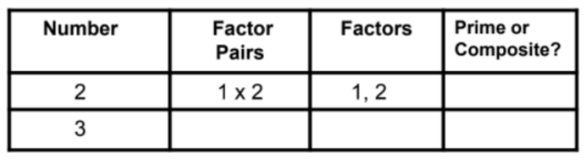

* + Describe any patterns that you notice in the factors and rectangular arrays. Suppose you were to continue looking at factors of numbers beyond 25. Predict the next two numbers that will have at least 3 factors. Explain your reasoning.

**Unit 3:**

* **Multiplication Tic-Tac-Toe**
  + Students can play Multiplication tic-tac-toe with anyone at home. Students will need 3 sheets of white paper. On the first sheet, draw a large tic-tac-toe board with multiplication facts inside each square. The other two sheets will be used for each player to show their work while solving the problem. Determine which player will be “X” and which player will “O”. One your turn, choose a spot on the tic-tac-toe board and then use the blank tic-tac-toe board to solve the problem in the correct spot on the board. The other player checks the work (or uses a calculator). If correct, the player may place an X or O on top of the multiplication problem they solved correctly. Play continues until one player has three in a row. Example pictures have been provided below to help with understanding the creation of the board.

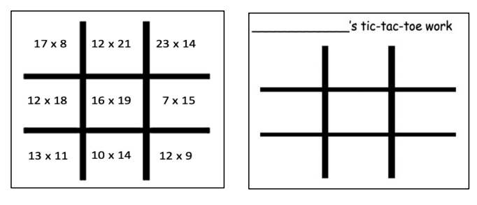

* **Largest/Smallest Product Game**
  + To play this game, families will need a deck of cards (Ace = 1, only use number cards 1-9). You may use a calculator to check the answers throughout this game. Players with an incorrect answer may lose a point or earn zero points for that round.
    - Version 1: Largest Product
      * Shuffle the cards and place them face down in a pile. Each player takes 3 cards from the deck and arranges them (2 digit by 1 digit) to make the largest product. Each player will solve the problem and the player with the largest product earns 1 point. Play until one player reaches 5 points.
      * Repeat the game with 4 cards and arrange the cards 2 digit by 2 digit.
    - Version 2: Smallest Product
      * Shuffle the cards and place them face down in a pile. Each player takes 3 cards from the deck and arranges them (2 digit by 1 digit) to make the smallest product. Each player will solve the problem and the player with the smallest product earns 1 point. Play until one player reaches 5 points.
      * Repeat the game with 4 cards and arrange the cards 2 digit by 2 digit.
* **Would You Rather?**
  + Below is an example of “Would You Rather” from The Math Learning Center. This is a great discussion starter. This conversation can be carried out as you continue to purchase items in stores. It provides a real-world application for the use of liquid volume, multiplication, and division. this idea can also be extended using mass. [Would You Rather? Fun in the Sun | Math At Home](https://mathathome.mathlearningcenter.org/activity/1947)
* **Elapsed Time**
  + There are many opportunities for families to engage in elapsed time scenarios. For example, families can put together itineraries for family trips or plan their day knowing what time they will start their activities and what time they would like to end.

**Unit 4:**

* **Equivalent Fractions**
  + Cooking is a great way to engage families in fractions. Families can use the 1/4 cup instead of the 1/2 cup and have the student determine how many of the 1/4 cups are needed to equal 1 of the 1/2 cups.
  + [Thumbprint Cookie Recipe](https://www.loveandlemons.com/thumbprint-cookies/)
* [Fraction Capture](https://www.georgiastandards.org/Georgia-Standards/Documents/Foundations-of-Algebra/Day-2-Segment-10-Fraction-Capture-from-Everyday-Math.pdf)
  + A great game to play together at home is Fraction Capture. You will need two 6-sided dice to play. This game reinforces several foundational fraction skills and concepts, such as fraction equivalence, comparing fractions to the benchmark of 1/2, and decomposing fractions.
  + A simple home-based application of equivalent fractions is to measure liquids using various measuring spoons or measuring cups. Have your child try to make equivalent amounts using a variety of spoons/cups and record the results in a math journal. Always encourage your child to make a prediction before actually measuring.
* **Comparing Fractions Game**
  + Families can also use a deck of cards to play a comparing fractions game from education.com. This two-player math game will improve your kid's fraction knowledge in a flash! Using just a deck of cards, pencils and paper you can create a more interesting way to practice an important skill. The objective of the game is to work together to determine who has created the largest fraction. Students can then write a fraction comparison statement using >, =, or <.

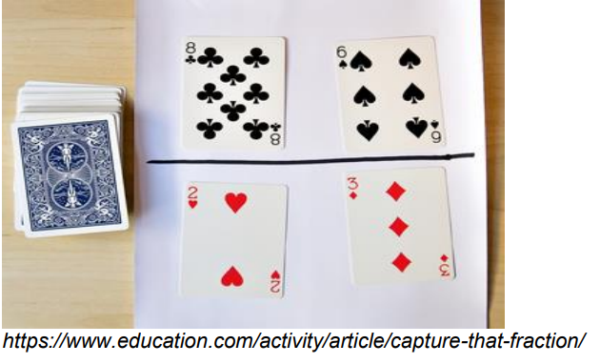

* **Comparing Fractions**
  + Share the Open Middle Website with families. [https://www.openmiddle.com/whats_open_middle/](https://www.openmiddle.com/category/grade-4/) At this point, Open Middle problems have been used in class and students should be able to guide their families in understanding the problems. Encourage families to engage in the Comparing Fractions task. Students may print the task at home or rewrite the problem on blank paper. Students may use an index card or piece of paper to write the digits 1-9 and then cut apart. This will allow the students to manipulate the numbers without rewriting the problem several times. Comparing Fractions Directions: Use the digits 1 to 9, at most one time each, to fill in the boxes to create two different fractions: one that is less than one half and one that is more than one half.

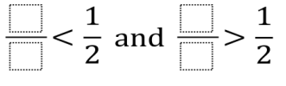

* **Adding Unit Fractions**
  + The best place to experiment with adding unit fractions is in the kitchen. Encourage families to cook using only the 1/4 or 1/3 measuring cups and spoons. This will provide students with an example of where this understanding will be used.
* **Mixed Numbers Practice**
  + Families can engage in a long jump competition of their own totaling their jumps from 3 rounds to determine the winner. Students can measure to the nearest quarter or eighth of an inch when recording jumps.

**Unit 5:**

* **Pretzel Stick Angles**
  + Students can engage with their families by making pretzel stick angles. Grab a bag of pretzel sticks or pretzel rods and a paper plate. Combine the endpoint of two pretzel sticks to make angles. What is the mathematical name for the pretzel stick?
  + Practice creating right angles, acute angles, and obtuse angles. Label each angle with a pencil or marker on the paper plate.
* **Estimating Angles**
  + Using the wedges created or any right angle/corner, families can estimate various angles that they find around the house or in the neighborhood. Discuss whether the angle is right, acute, or obtuse and then estimate and measure how many wedges it may be. Families can use the wedges created in class or use the directions below to create their own. Begin by making a circle on wax paper or construction paper by tracing a circular object such as a mixing bowl or glass.

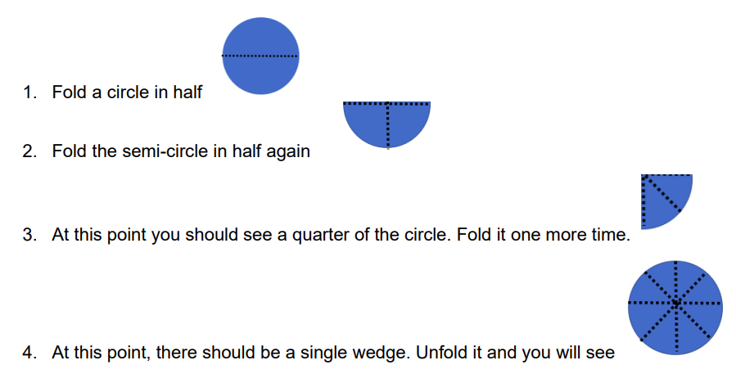

* **Angles in Circles Game**
  + Play the Angles in Circles game with a family member using a die that has more than 6 numbers. Online polyhedral dice is available [here](https://diceroll.fun/). Compare the angle measures determined using 360 degrees.
* **Protractor Practice**
  + Using a straightedge, take turns with your child drawing angles on a piece of paper. Make a game of it. After drawing an angle, you, and your child both guess how many degrees the angle measures. Measure the angle with a protractor to see whose guess was closest.

**Unit 6:**

* **Name Game**
  + One independent task could be for students to write their names on graphing paper and identify how many angles are right, obtuse, and acute. To extend this activity: the parent can ask students to identify which lines are segments, potential rays, as well as the perpendicular and parallel lines.
* **Symmetry**
  + Families can look for lines of symmetry in items in their houses, for example on rugs, blankets, table clothes, etc.
  + Guardians write their child’s name in block letters on a piece of paper and ask children to identify how many lines of symmetry each letter of their name has.
  + Families can explore the website, <https://www.didax.com/apps/pattern-blocks/>
* **Exploring Area**
  + Families can print one inch graph paper from the website, <https://madisonpaper.com/1-inch-graph-paper/> and ask their child to draw a “blob”.
  + Each family member shares their estimate of the area of the blob.
  + Families should note that the estimate would include square inches.
  + Using the one-inch graph paper from above, trace the hand of the child. Each family member estimates the area of the child’s hand.
  + Families should note that the estimate would include square inches.
  + Parents can share examples of when they must calculate area, for example, painting a room, carpeting a room, installing counter tops, tiling an area, etc.
  + Try this paper folding activity to reinforce the idea that equal areas do not necessarily have to be congruent (identical, or same size and same shape).
    - Open Middle tasks encourage critical thinking and the use of number sense.
    - Try these out:
      * <https://www.openmiddle.com/area-perimeter-of-a-rectangle/>
      * <https://www.openmiddle.com/area-of-a-rectangle/>
      * <https://www.openmiddle.com/rectangles-maximizing-area/>
      * <https://www.openmiddle.com/rectangles-maximizing-perimeter/>
  + Analyze the floor plans of living spaces in your vicinity and calculate the total area of the living space.
* **LEGOS!!**
  + Families build composite figures using building blocks (Legos) and discuss the area of the composite figures.