Name:__________________________ Date:___________________

Ecosystems

In the table below, write a short definition for producers, consumers, and decomposers and include 3 examples of each. Then, draw a picture of one of the examples you chose.

Producers | Consumers | Decomposers
Definition:  Examples:  -  -  -  Picture: | Definition:  Examples:  -  -  -  Picture: | Definition:  Examples:  -  -  -  Picture:
Flow of Energy

Use the word bank below to label the food chain. Then, answer the question at the bottom of the page.

decomposer producer secondary consumer

sunlight tertiary consumer primary consumer

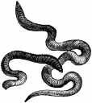
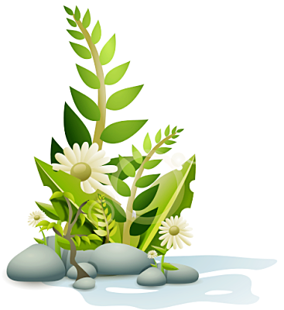
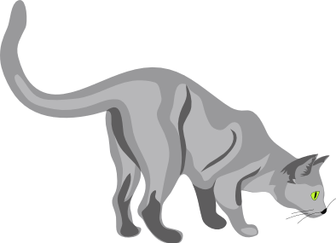
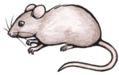
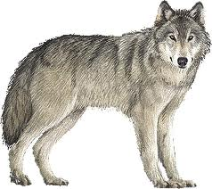
How does the flow of energy go through the food chain? Where does this energy come from?

On Your Own!

Now, use the space below to create your own food chain. Be sure to include sunlight, a producer, a primary consumer, a secondary consumer, a tertiary consumer, a decomposer, and arrows that show the flow of energy. Also, make sure your food chain makes sense, and don’t forget to label!

Energy Pyramid

Use the word bank below to fill in the energy pyramid. Also, provide an example of each!

producer secondary consumer

tertiary consumer primary consumer

