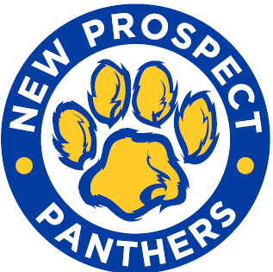
COLLEGE SPIRIT WEEK
September 20-24, 2021
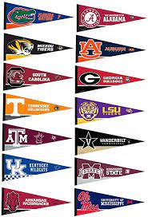
Monday | Our Future is BRIGHT!  Wear bright or neon colors
Tuesday | DREAM About your Future!  Wear your coziest pajamas
Wednesday | HATS off to a Great Future!  Wear your favorite hat
Thursday | We are COLLEGE BOUND!  Wear a college shirt or jersey
Friday | Dress for SUCCESS!  Smile and dress for success  and to impress

Join us as we celebrate being
“college and career ready”
at New Prospect Elementary!

